4. Suppose you want to test the claim that μ 1 < μ 2. Two samples are random, independent, and come from populations that are normally distributed. The sample statistics are given below. Assume that = . At a level of significance of when should you reject H 0?

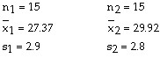

3. Test the claim that μ 1 > μ 2. Two samples are random, independent, and come from populations that are normally distributed. The sample statistics are given below. Assume that ≠ . Use α = 0.01.
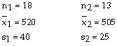

5. A local bank claims that the waiting time for its customers to be served is the lowest in the area. A competitor's bank checks the waiting times at both banks. Assume the samples are random and independent, and the populations are normally distributed. Test the local bank's claim: (a) assuming that = , and (b) assuming that ≠ . Use α = 0.05. 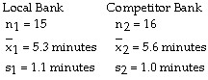
6. Find the standardized test statistic, t, to test the claim that μ 1 = μ 2. Two samples are random, independent, and come from populations that are normally distributed. The sample statistics are given below. Assume that 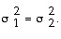
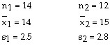
-1.101 -1.326
-0.813 -0.962
7. Find the standardized test statistic, t, to test the claim that μ 1 < μ 2. Two samples are random, independent, and come from populations that are normally distributed. The sample statistics are given below. Assume that
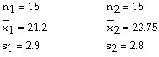
-2.450 -0.669
-3.165 -1.667
8. A recent survey showed that in a random sample of 100 elementary school teachers, 15 smoked. In a random sample of 180 high school teachers, 36 smoked. Is the proportion of high school teachers who smoke greater than the proportion of elementary teachers who smoke? Use α = 0.01.
9. A youth prevention organization is examining the effect of parental smoking on the decision of their teenagers to smoke. A survey of 1150 teenagers, ages 11 to 17 years who smoked in the last 30 days, was conducted. The random sample consisted of 500 teenagers who had at least one parent that smoked and 650 who had parents that did not smoke. The results are shown in the figure. At , can you support the organization's claim that the proportion of teens who decide to smoke is greater when one or both of their parents smoke?
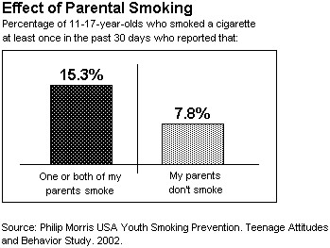
10. Find the standardized test statistic, z to test the claim that p 1 = p 2. Assume the samples are random and independent. Sample statistics: n 1 = 50, x 1 = 35, and n 2 = 60, x 2 = 40
0.374 1.328
2.361 0.982

11. Find the weighted estimate, to test the claim that p 1 = p 2. Use α = 0.05. Assume the samples are random and independent. Sample statistics: n 1 = 50, x 1 = 35, and n 2 = 60, x 2 = 40
0.328 0.682
0.238 1.367
12. Find the standardized test statistic, z, to test the claim that p 1 < p 2. Assume the samples are random and independent. Sample statistics: n 1 = 550, x 1 = 121, and n 2 = 690, x 2 = 195
-2.513 1.116
-2.132 -0.985
13. Find the weighted estimate, , to test the claim that p 1 < p 2. Use α = 0.10. Assume the samples are random and independent. Sample statistics: n 1 = 550, x 1 = 121, and n 2 = 690, x 2 = 195
0.730 0.255
1.116 0.338
14. A nutritionist believes that obesity is more prevalent among American adults than it was in the past. He discovers that in a study conducted in the year 1994, 380 of the 1630 randomly chosen adults were classified as obese. However, in a more recent study, he finds 726 out of 2350 randomly chosen adults were classified as obese. At α = 0.05, do these studies provide evidence to support the nutritionist's claim that the proportion of obese adults has significantly increased since 1994?
15. A medical researcher suspects that the pulse rate of smokers is higher than the pulse rate of non-smokers. Test the researcher's suspicion using α = 0.05. Assume the two samples are random and independent.
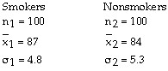
16. A recent study of 100 elementary school teachers in a southern state found that their mean salary was $24,700 with a population standard deviation of $2100. A similar study of 100 elementary school teachers in a western state found that their mean salary was $35,100 with a population standard deviation of $3200. Test the claim that the salaries of elementary school teachers in the western state is more than $10,000 greater than that of elementary teachers in the southern state. Use α = 0.05. Assume the two samples are random and independent.
17. Find the standardized test statistic to test the claim that μ 1 > μ 2. Assume the two samples are random and independent.
Population statistics: σ 1 = 45 and σ 2 = 25
Sample statistics: 1 = 480, n 1 = 100 and 2 = 465, n 2 = 125
2.99 2.81
0.91 1.86
18. Find the standardized test statistic to test the claim that μ 1 = μ 2. Assume the two samples are random and independent.
Population statistics: σ 1 = 1.5 and σ 2 = 1.9
Sample statistics: 1 = 24, n 1 = 50 and 2 = 22, n 2 = 60
4.2 6.2
3.8 8.1
19. A local bank claims that the waiting time for its customers to be served is the lowest in the area. A competitor bank checks the waiting times at both banks. Test the local bank's claim using α = 0.05. Assume the two samples are random and independent.
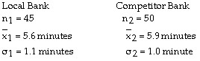
20. At a local college, 65 female students were randomly selected and it was found that their mean monthly income was $616 with a population standard deviation of $121.50. Seventy-five male students were also randomly selected and their mean monthly income was found to be $658 with a population standard deviation of $168.70. Test the claim that male students have a higher monthly income than female students. Use α = 0.01.
21. Find the standardized test statistic to test the claim that μ 1 = μ 2. Assume the two samples are random and independent.
Population statistics: σ 1 = 2.5 and σ 2 = 2.8
Sample statistics: 1 = 3, n 1 = 40 and 2 = 4, n 2 = 35
22. As part of a Master's thesis project, a mathematics teacher is interested in the effects of two different teaching methods on mathematics achievement. She randomly chooses one class of students to learn an algebraic concept using traditional methods and another class of students to learn the same algebraic concept using manipulatives. The teacher then compares their test scores. Determine whether the samples are dependent or independent.
Independent
Dependent
23. As part of a marketing experiment, a department store regularly mailed discount coupons to 25 of its credit card holders. Their total credit card purchases over the next three months were compared to their prior credit card purchases during the previous three months. Determine whether the samples are dependent or independent.
Independent
Dependent
24. Classify the two given samples as independent or dependent.
Sample 1: Pre-training weights of 18 people
Sample 2: Post-training weights of 18 people
Dependent
Independent
25. Classify the two given samples as independent or dependent.
Sample 1: The weights in pounds of 21 newborn females
Sample 2: The weights in pounds of 21 newborn males
Dependent
Independent
26. A nutritionist believes that obesity is more prevalent among American adults than it was in the past. He discovers that in a study conducted in the year 1994, 380 of the 1630 randomly chosen adults were classified as obese. However, in a more recent study, he finds 726 out of 2350 randomly chosen adults were classified as obese. Construct a 95% confidence interval for the difference in proportions
27. Construct a 95% confidence interval for p 1 - p 2. Assume the samples are random and independent.
Sample statistics: n 1 = 50, x 1 = 35, and n 2 = 60, x 2 = 40
(-1.341, 1.781) (-0.141, 0.208)
(-0.871, 0.872) (-2.391, 3.112)
28. Construct a 99% confidence interval for data sets A and B. Data sets A and B are random and dependent, and the populations are normally distributed. Round to the nearest tenth.
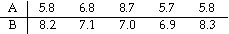
(-15.1, 15.1) (-4.5, 2.6)
(-21.3, 19.0) (-25.1, 5.8)
29. Construct a 95% confidence interval for data sets A and B. Data sets A and B are random and dependent, and the populations are normally distributed. Round to the nearest tenth.
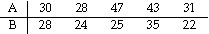
30. Find the critical values, t0, to test the claim that μ1 = μ2. Two samples are random, independent, and come from populations that are normal. The sample statistics are given below. Assume that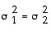 .
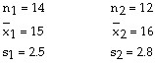
±2.492 ±2.201
±2.064 ±1.318

31. Find the critical value, t 0, to test the claim that μ 1 > μ 2. Two samples are random, independent, and come from populations that are normal. The sample statistics are given below. Assume that 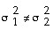 .
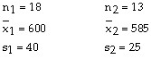
3.055 2.179
1.699 2.681
32. Find the critical value, t 0, to test the claim that μ 1 ≠ μ 2. Two samples are random, independent, and come from populations that are normal. The sample statistics are given below. Assume that .
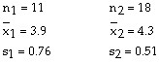
±3.169 ±2.228
±2.764 ±0.684

